Knowledge Mile

1. What problem are we planning to solve, and why is it important?
Riga is falling behind its Baltic neighbours in terms of economic growth. In 2000, Riga and Vilnius had the same GDP per capita. By 2023 (Eurostat), Vilnius was at 131% of the EU average and Riga at 101% (refer to Appendix 1). Latvia ranks 25th of 27 in the European Innovation Scoreboard 2026, at 61% of the EU average. It is roughly flat since 2019, while Estonia and Lithuania each gained about 20 points. Vilnius start-ups raised about €212m of venture capital in 2025, roughly 2.5 times Riga’s.
However Riga’s one clear strength is its students. Riga ranks 105th in the QS Best Student Cities 2027, ahead of Vilnius (=114th) and Tallinn (=135th). Eventhough Latvia's population is declining, international student numbers have more than doubled in a decade, from 5,255 in 2014 to 11,895 in 2025, or 15.6% of all students. In Pārdaugava, five universities (LU, RTU, RSU, RISEBA and BA Turība), two clinical hospitals and the National Library sit within about 3 km. They host roughly 30,000–40,000 students and 4,000 researchers. This “Knowledge Mile” (Zināšanu jūdze) is a way Riga can turn talent into firms, jobs and residents.

2. What does the research and data say?
How big is the problem?
Bank of Latvia economist O. Krasnopjorovs estimates that Riga lags Vilnius and Tallinn by 7–8 years in income and diverged from Vilnius after 2010. On innovation, Latvia’s R&D spending was 0.94% of GDP in 2024 (Lithuania 1.12%, Estonia 1.98%). Only 44.7% of Latvians aged 25–34 hold a tertiary degree, against 60.8% in Lithuania. Government R&D budgets are €104 per inhabitant, against €138 in Lithuania and €284 in Estonia. Another challenge is students leaving after finishing their studies: RSU reports that only about 5% of its foreign graduates stay, while Estonia keeps about half of its international students for five years (OECD). LaSER estimates that higher-education exports are worth about €385m a year, just under 1% of GDP. Retaining and expanding this is a direct economic gain.
Why the problem exists, and how it can be solved.
The Knowledge Mile has the first factor of Boschma’s proximity framework: geographical proximity, but lacks the others: organisational, institutional and social proximity.
Causal studies show that cheap coordination closes this gap:
- In a randomised experiment at Harvard Medical School (Boudreau et al. 2017), a 90-minute structured matchmaking session raised scientists’ probability of co-applying for grants by 75%, even within one institution.
- In Silicon Valley, a quarter fewer face-to-face meetings would mean about 8% fewer patent citations (Atkin et al. 2022).

Other countries both in Baltics and elsewhere have examples of what works:
City | Institution | City’s role
Tartu | Science park foundation (1996) | Co-founder with the University of Tartu, the county and institutes
Vilnius | Sunrise Valley science and technology park (2003); national “valleys” programme | Co-founder with Vilnius University and VILNIUS TECH; runs the agency Go Vilnius
Tallinn | Ülemiste City and Tehnopol next to TalTech | Co-funds a TalTech “Future City” professorship with the district’s developers
Tampere | City–university agreement for 2026–2029 | Work programme and a management group meeting four times a year
Eindhoven | Brainport foundation and development agency | About €1 per inhabitant from municipalities, plus about €2 raised from other sources for each public euro
Leiden–Delft | Leiden Bio Science Park & TU Delft Campus | Co-funder of local innovation parks/hubs
Riga | Memoranda (2023, 2024) | Signatory only: no entity, budget or KPIs

What impact can we expect?
The goal is to raise the yield of the universities Riga already has. Matchmaking sessions for 10% of the Mile’s researchers would, on Boudreau’s estimates, create about 95 additional collaborating pairs a year. Every 1,000 additional international students retained or attracted brings roughly €15m a year in direct spending (on LaSER’s per-student figure). We do not claim that governance alone causes growth, so we propose pre-registered KPIs and a comparison with Tallinn and Vilnius.

3. What should be done, and how will we make an impact?
IZM has stated that recognition of cross-university electives is up to each institution, no national law forbids them, and LU’s rules already allow it. The barrier is implementation and coordination between universities. We therefore propose three possible options, each with a specific person or an institution responsible
- Riga City Council (Mayor Viesturs Kleinbergs; Deputy Mayor Vilnis Ķirsis, who signed the 2024 memorandum as mayor) writes a Knowledge Mile chapter into the Riga 2050 strategy and Development Programme 2028–2034, whose drafting started on 29 October 2026. The chapter would: create a coordinator post in the Executive Director’s office with a base budget of about €0.6m a year, with a target of raising two external euros for each city euro; replace the 2024 memorandum with a five-year partnership agreement and work programme that adds RISEBA, BA Turība, student councils and businesses; require an annual public progress report.
- The five rectors sign a Knowledge Mile Study Agreement. It would contain: a shared catalogue of free-choice courses, automatic recognition, a cap of two courses per semester, reserved seats for partner students, home-pays clearing between universities. This needs no law change and can be piloted in autumn 2027.
- The Ministry of Education and Science and AIC add an explicit clause, when they draft the regulation that must replace Cabinet Regulation No. 793 before it lapses on 1 January 2028. The clause would allow the free-choice part to be completed at a partner institution under such an agreement.

References:
Atkin, D., Chen, M. K., & Popov, A. (2022). The returns to face-to-face interactions: Knowledge spillovers in Silicon Valley (NBER Working Paper No. 30147). National Bureau of Economic Research. https://doi.org/10.3386/w30147
Boschma, R. (2005). Proximity and innovation: A critical assessment. Regional Studies, 39(1), 61–74. https://doi.org/10.1080/0034340052000320887
Boudreau, K. J., Brady, T., Ganguli, I., Gaule, P., Guinan, E., Hollenberg, A., & Lakhani, K. R. (2017). A field experiment on search costs and the formation of scientific collaborations. The Review of Economics and Statistics, 99(4), 565–576. https://doi.org/10.1162/REST_a_00676
Catalini, C. (2018). Microgeography and the direction of inventive activity. Management Science, 64(9), 4348–4364. https://doi.org/10.1287/mnsc.2017.2798
Dealroom. (2026). Riga startup ecosystem [Data set]. Retrieved November 1, 2026, from https://dealroom.co/cities/riga/
European Commission. (2026). European Innovation Scoreboard 2026. Publications Office of the European Union. https://doi.org/10.2777/4615399
Eurostat. (2026a). Gross domestic product (GDP) at current market prices by NUTS 3 regions (nama_10r_3gdp) [Data set]. https://doi.org/10.2908/nama_10r_3gdp
Eurostat. (2026b). Gross domestic expenditure on R&D (GERD) by sector of performance (rd_e_gerdtot) [Data set]. https://ec.europa.eu/eurostat/databrowser/view/rd_e_gerdtot/default/table
Eurostat. (2026c). Population by educational attainment level, sex and age (edat_lfse_03) [Data set]. https://ec.europa.eu/eurostat/databrowser/view/edat_lfse_03/default/table
Go Vilnius. (2026, January 27). Vilnius startups raise €215m in VC. https://www.govilnius.lt/vilnius-startups-raise-215m-in-vc
Krasnopjorovs, O. (2022). Ready for the next 820? Looking for the keys to paradise of Riga city (Discussion Paper No. 2/2022). Latvijas Banka.
LaSER. (2025). Ārvalstu studenti Latvijā: izaugsmes avots? [International students in Latvia: A source of growth?]. Latvijas Stratēģijas un ekonomikas risinājumu institūts. https://domnicalaser.lv/arvalstu-studenti-latvija-izaugsmes-avots/
LaSER. (2026). Rīgas Zināšanu jūdze (2.0) [The Riga Knowledge Mile (2.0)] (D. Auers & U. Spuriņš, Eds.). Latvijas Stratēģijas un ekonomikas risinājumu institūts.
Latvijas Sabiedriskie mediji. (2025, December 4). Latvia remains low in EU R&D league. LSM.lv. https://eng.lsm.lv/article/society/education/04.12.2025-latvia-remains-low-in-eu-rd-league.a625105/
Ministru kabinets. (2018). Studiju virzienu akreditācijas noteikumi (MK noteikumi Nr. 793) [Regulations on the accreditation of study directions]. https://likumi.lv/ta/id/303956
OECD. (2022). International migration outlook 2022. OECD Publishing. https://doi.org/10.1787/30fe16d2-en
Oficiālās statistikas portāls. (2026). Mobile students in Latvia by sex, country of previous education, type of institution, field of education and education level (IGA050) [Data set]. Centrālā statistikas pārvalde. https://data.stat.gov.lv
QS Quacquarelli Symonds. (2026). QS Best Student Cities 2027. https://www.topuniversities.com/city-rankings
Rīga Stradiņš University. (n.d.). By attracting international students, RSU's impact on the Latvian economy could reach one billion euros by 2030. https://www.rsu.lv/en/node/279683

Appendix
Appendix 1. GDP per inhabitant in Riga, Vilnius and Tallinn, 2000–2024
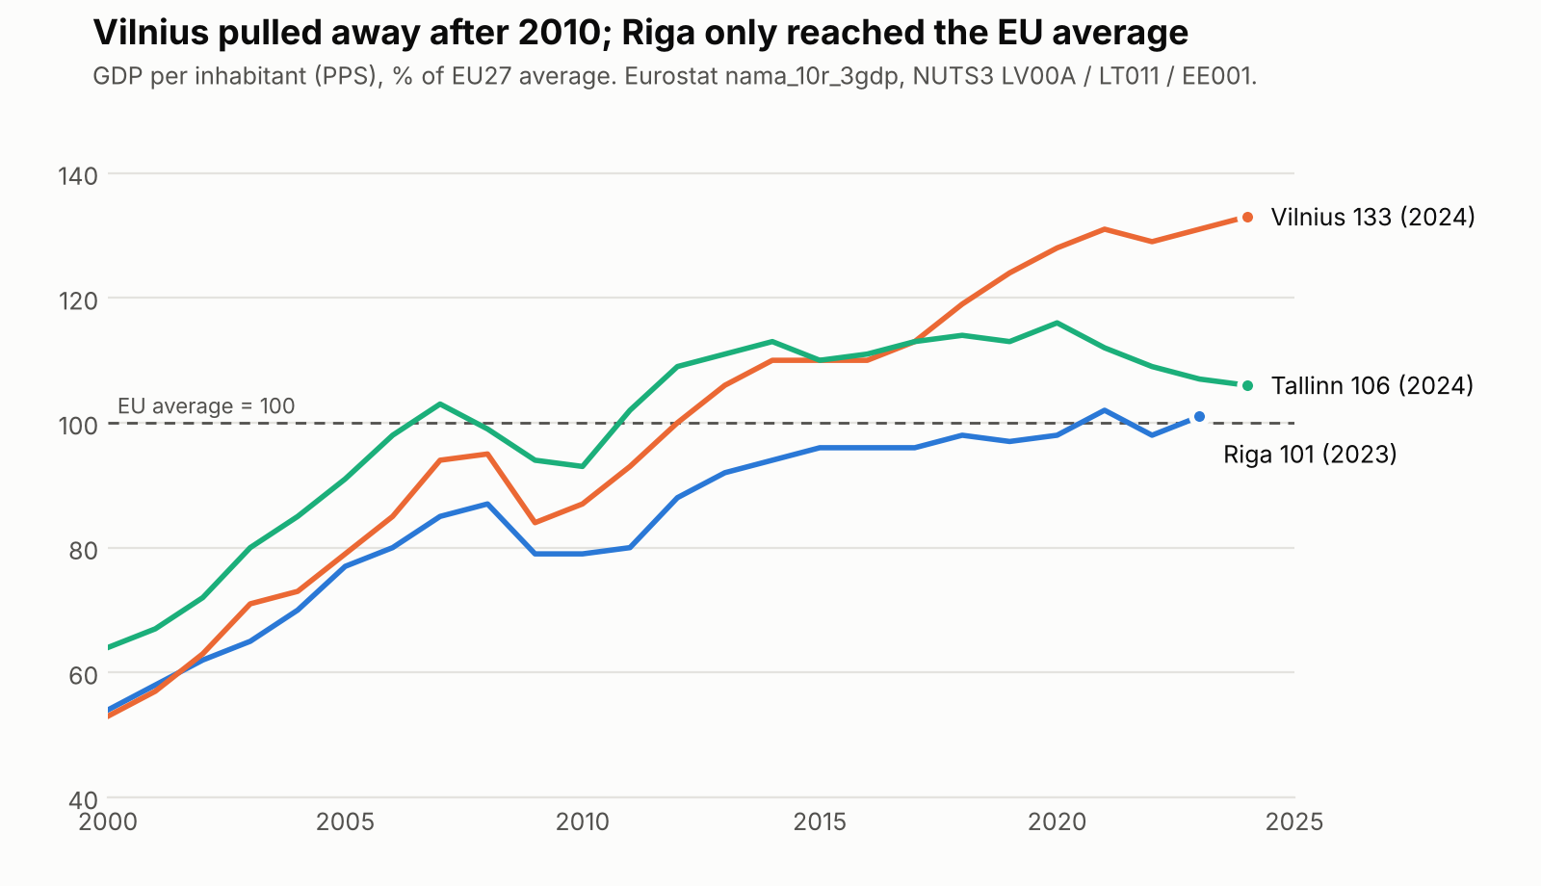
Note: GDP per inhabitant in purchasing power standards (PPS), % of EU27 average. Source: Eurostat (2026a), NUTS 3 regions LV00A (Riga), LT011 (Vilnius) and EE001 (Tallinn). Riga's 2024 figure was not yet published.
Appendix 2. Research methodology and conceptual frameworks of the key research used
Boschma (2005) – conceptual framework: proximity
Conceptual framework: proximity and innovation, distinguishing five dimensions – cognitive (shared knowledge base), organisational (shared arrangements or networks), social (trust-based relations), institutional (shared rules and norms) and geographical (physical distance). Methodology: a critical review of the economic-geography and innovation literature. Core argument: geographical proximity is neither necessary nor sufficient for interactive learning; it only works together with the other dimensions, and too much proximity can cause lock-in. We use it to diagnose why five co-located universities do not yet collaborate.
Boudreau et al. (2017) – randomised field experiment
Conceptual framework: search costs in forming collaborations – scientists may fail to collaborate because finding suitable partners is costly, even when they are nearby. Methodology: a natural field experiment at Harvard Medical School; scientists attending a symposium linked to a grant call were randomly assigned to 90-minute structured information-sharing sessions, and pairs sharing a session were compared with pairs that did not on whether they later co-applied for a grant. Result: co-application probability rose by 75% (0.16% to 0.28%). Randomisation gives a causal estimate; the limitation is one elite institution and one outcome.
Atkin, Chen & Popov (2022) – observational study with smartphone data
Conceptual framework: localised knowledge spillovers transmitted through face-to-face interaction. Methodology: anonymised smartphone location data are used to measure face-to-face meetings between workers of different technology firms in Silicon Valley and are linked to patent citations between those firms; an instrumental-variables strategy separates the effect of meetings from firms' prior knowledge links. Result: 25% fewer meetings imply about 8% fewer citations. NBER working paper (not yet peer reviewed).
Catalini (2018) – natural experiment
Conceptual framework: micro-geography and search costs in the recombination of ideas. Methodology: asbestos removal at the Jussieu campus in Paris forced laboratories to relocate for reasons unrelated to research, creating quasi-random variation in which labs became neighbours; collaboration of co-located and separated lab pairs is compared. Result: co-location made two labs 3.5 times more likely to collaborate, mostly for pairs that previously faced high search costs.
LaSER (2026) – qualitative policy study of the Riga Knowledge Mile
Conceptual framework: the Knowledge Mile as an urban knowledge cluster and student city, assessed through governance, housing, mobility, public space and commercialisation. Methodology: desk research and administrative data (Rīgas satiksme, Ministry of Education), 16 in-depth interviews on research commercialisation, interviews with universities and Riga City Council deputies, student focus groups with mental mapping, and GIS mapping of services and land ownership. Descriptive, without causal analysis; it provides the local diagnosis (no owner, KPIs or budget behind the 2024 memorandum).

